Restoring Bykle Kyrkje 2001/2002

Final Report

Referring to the work plan from Anders Haslestad, Norwegian Directorate for Cultural Heritage, 10 May 2001 (survey)
Referring to subreport by Olav H. Rygnestad, 18 October 2001
Referring to report from master painter Gunnar Gundersen, Frolands Verk, 15 August 2001
Referring to report from Daniel Addey-Jibb, 1 July 2001
Referring to installation report from Olav K. Hovet

The numbers in the right margin refer to photographs attached to the original report submitted to Bykle Sokneråd (The photographs are not included in this electronic version)

----------------------------------------------------------------------------------------------------------------

ENTRANCE VESTIBULE

External panels were marked and removed (front side)
The door sill had extensive rot damage 1.
Reconstructed the sill and joined it in place. 2.
Installed external panels. Photos shows that new materials were used 3.
Hand-forged nails were used (blacksmith: Olav J. Rysstad, Rysstad).
Surface treatment (see report from master painter).
The door was restored with one new crosspiece and a new threshhold.
The foundation wall was dismantled and reinstalled on crushed rock.
Dismantled the floor boards and joists (three) due to rot damage. The ground was lowered to allow air under the joists/boards and reduce the absorption of moisture.
Three joists and five floor boards were reconstructed. 4.
Photo number 5 shows the new floor boards, the old ones had been replaced earlier. 5.
Referring to the surface treatment report (Gunnar Gundersen).

Wall CC
The corner panel was lowered due to rot damage in the lower parts (see ground plan, Addey-Jibb) 6.
Traces were found of black and white paint (ashlar shape).

Wall II was scraped and painted. 7.

STAIRS
The stairs were dismantled (concrete) and the small flagstones were removed (see subreport). The flagstone in front of the door is the original, the flagstones lie in crushed rock. 8-9 and 10.

NAVE GABLE - END WALLS

Wall III
Dismantled external panels 11.
Rot damaged sill was bunged up (inserted) with new wood. The foundation wall was laid in crushed rock. 12-13.
The photo shows the use of new wood materials - scraped and painted. 14.
Joists were impregnated against parasites during the last restoration. There is no rot damage on these. Ca. 40-50 cm free height (dry) 15.

Wall III.
Attached single panels with hand-forged nails. Scraped and painted. 16.
The foundation wall remains the same to support internal joists.

Wall V.
The foundation wall was straightened. Scraped and painted.

Wall Y.
Dismantled external panels. Rot damage was found on sill and corner. 18.
Rot damage was removed and the foundation wall supported. Due to rot damage the wall had settled quite a bit in the corner. Rot damage was removed and supported with a flagstone. We did not attempt to adjust the wall CCC due to the support for the joists. External panels were then replaced, scraped and painted.

Wall CCCC.
Scraped and painted. 19.

Wall CCC.
Dismantled the foundation wall and external panels.
The sill was rot damaged. 20-21.
The sill was bunged up with new material and the wall was replaced. 22.
External panels were replaced. Photo shows the use of new materials. Scraped and painted. 23.

CHANCEL
Wall VI.
Dismantled the foundation wall to examine the joists and floorboards. The joists were lying in dry boggy soil with minor rot damage. The joist foundations were straightened up. The foundation wall was replaced on crushed rock. Scraped and painted. 27-28.

Wall VIII
Hand-forged nails used to tighten lose panels. Scraped and painted. 29.

Wall YC
Dismantled external panels. 30.
Rot damaged sill 31-32.
Dismantled the foundation wall to examine the joists. Minor rot damage. Straightened up the foundations.
Bunged up rot damaged sill with new material. 30.
Replaced rot damaged cornice. Lowered some wall panels due to rot damage in the lower parts.
Photo shows use of new materials. Scraped and painted. 33.
Details.
Photos shows one panel fixed with wooden nails. 34.
Some panels were turned around. There were visible evidence of tar treatment and use of wooden nails. 35-36.
Restoration was completed in 2001.

BELL TOWER
Restoration started 10. June 2002.
The detached scaffolding was built by Ivar Pedersen, Tveit. 40.
The church bell tower was scraped and painted. Photo shows use of new materials.
41-42.
The door to the peephole was straightened up with forged hinges and hooks.

ROOF
There was large rot damage on the roof panels. There were no damage to the nailing strip. Creosote impregnated 2” panels were used for the roof - same as for the entrance vestibule, nave gable, and chancel (completed in 1988-89). The ridge of the roof was covered with sink (replaced existing sink). The same pattern for drainage was used as before. 43.

WALL UNDER THE SPIRE
Replaced panels due to rot damage. Photo shows use of new materials. 43-44.
Used hand-forged nails. Scraped and painted.

SPIRE
Replaced panels due to rot damage under nailing strip around the bell tower (eight sided). 45.
Rot damage was found on the wooden (spruce) shingles. All shingles were dismantled. 45.
There is roofing felt (tar) on the roof boards. The boards were not rot damaged. 46.
There was no rot damage on the top spire and the knob. The photo shows the spire and its roof with roofing felt and glue. 47.

New shingles were made from spruce (see appendix 1)
The shingles were shaped with axe and impregnated on all sides with tar prepared in charcoal kiln. 47-48.
The tar was delivered by Fortidsminneforeningen (Organisation working for the protection of ancient artefacts). The tar was heated in a water bath before use.
The spire was tarred with 4 strokes. 47-48-49.
The top row of shingles was reused. 50.
See appendix 2 for a sketch of the weathervane.
The clock shaft was greased.

We were delayed by rain. Therefore, the restoration work took a long time with the danger of water and moisture damage to the church.

Most of the wooden material that was replaced is retained for documentation
The portal was changed (heightened) to allow passage for the new excavator. The side posts were replaced using heartwood. Creosote impregnated roof panels and gates were reused. The original foundations were retained. Painting was postponed till the spring.
----------------------------------------------------------------------------------------------------------------

The following people have contributed to the work:
Hallvard S. Nomeland Valle
Waheed Roomi Pakistan
Olav H. Rygnestad Valle

Assistance was contributed by Bykle Kommune (Municipality) by Trygve Gjerden (head of the outdoor section in Bykle Kommune).

Thank you for the commission and good cooperation with Helene Horverak, verger in Bykle Sokneråd.

Systog Rygnestad 4747 Valle 9 October 2002

Olav H. Rygnestad

Telephone number: 379 36 828
Mobile number: 95 83 67 66
Restoring Bykle Kyrkje 2001/2002

Final Report - Appendix 1

NEW SHINGLES

Standing spruce trees were selected at Anders Dalseg’s property, Bygland, on 17 June 2002 (during sap time). The trees had been growing very slowly. The shingles were cut perpendicularly. 51.
The shingles were dried in room temperature (+25°C). Moisture was monitored during the drying period.

Outer Inner
Day 1 23% 15%
Day 2 23% 11%
Day 3 17% 8%
Day 4 11% 8%
Day 5 11% 10%
Day 6 installed an electric dehumidifier
Day 9 (with +25°C temperature) 0% 0% 52.

Systog Rygnestad 4747 Valle 9 October 2002

(sign.)
Olav H. Rygnestad
Restoring Bykle Kyrkje 2001/2002
Final Report - Appendix 2 - Sketch of the weathervane
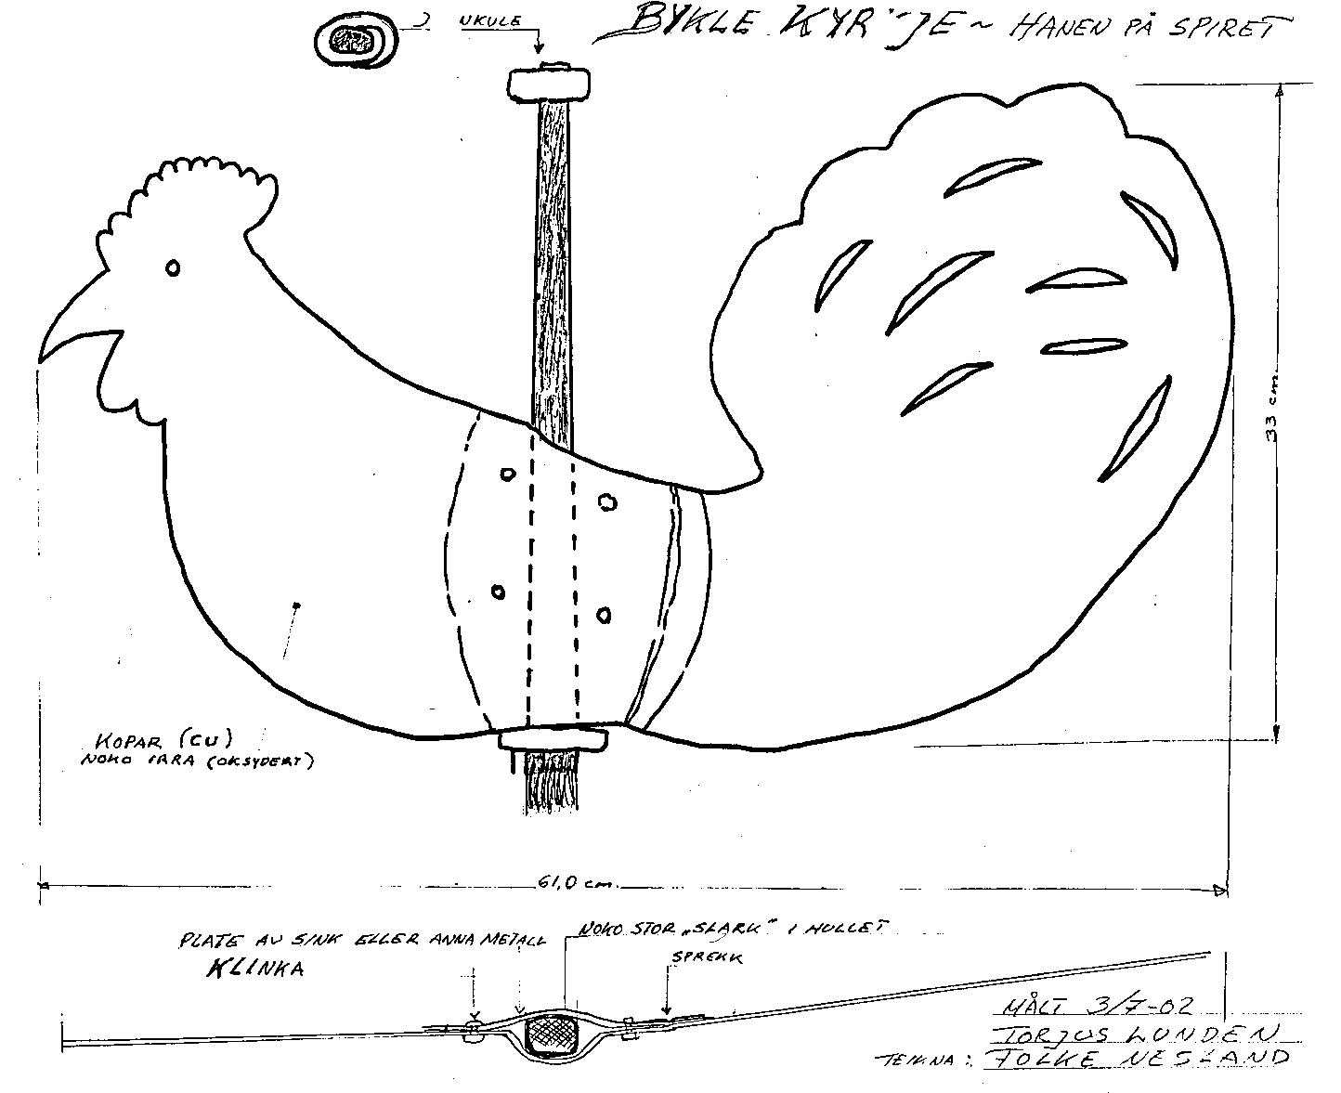
Copper (Cu)
Some oxidation
Sink or other metal - rivetted
Slightly loose fit
Crack

